Deliverable 0

System Overview

Simplified-Scheduler is a web application; its purpose is to create a valid multi-year schedule for a student. The aim is the make it simple for students to create a multiyear schedule as well as build upon the student record for a student. On the website you will be prompted to log in; once logged in the student can than build his/her schedule, and modify it as he chooses (assuming modifications are within rules). The system may auto generate a schedule for the student or the student can add classes manually. Further to this the student may add restrictions; the auto generate will take these restrictions and regenerate a schedule around those restrictions if it is possible, the application will let the student know if his restrictions make it impossible to complete the schedule. The restrictions can be certain times he does not desires or even an entire day he does not wish to have classes on. The restrictions will confine the schedule. //Further to restrictions the student has a set sequence to follow. Recommended it is to follow the sequence however students play around with their sequences quite a bit, the only way to know if their desired augmentations to the sequence is allowed is to verify if the course they wish to register in has pre-requisites and if they for fill requirements to register// going to remove this block

. The student record which every student has; has a list of completed classes; also as such the application will check if the student takes the required prerequisites any semester before the class he/she intends to register for. On the application the schedule will be displayed; and after each change the student may wish to display the updated schedule. The system will also keep track the schedules generated.

Doman Model Overview

The Domain Model shows that upon student login the student may create a schedule for each semester. The student will enter his preferences, which from the systems point of view are restrictions. The System will then check which courses are available from a Course Database. From there it will decide which courses fits the student’s constraints and it will display a Schedule for the student.

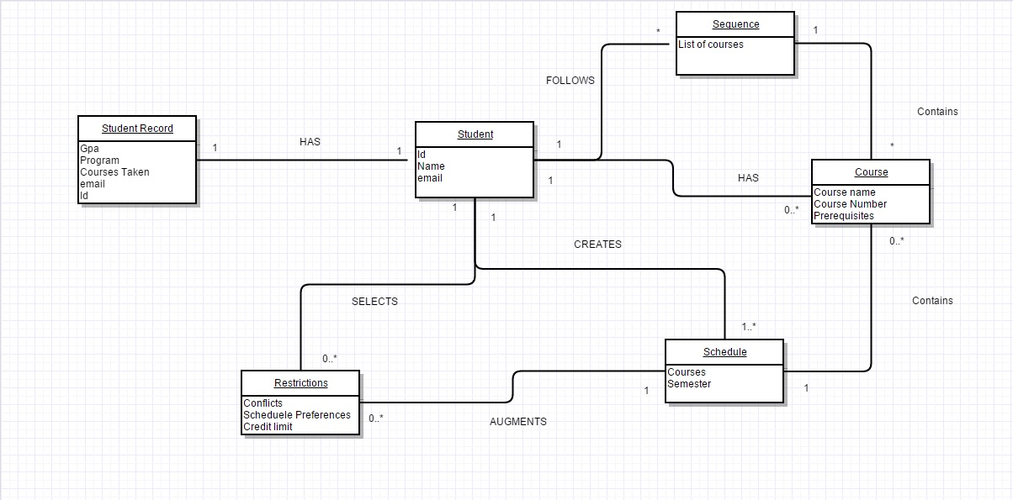

Team Details

Team name: Heilongjiang

Team Captain: Lance Lafontaine

List of team members and tentative roles

* Jason Tsalikis(25892120) , Documentation and Back end programming
* Bruce Choi
* ADD NAMES HERe